**Day 1**

**Table Creation and Data insertion**

create table book(Book_No int(6), Book_Name varchar(20), Author_name varchar(20), Cost int(7), Category char(20));

desc book;

insert into book values(101,'Let us C','Denis Ritchie',450,'System');

insert into book values(102,'Oracle – Complete', 'Loni', 550, 'Database');

insert into book values(103, 'Mastering SQL','Loni',250,'Database');

insert into book values(104, 'PL SQL-Ref', 'Scott Urman',750, 'Database');

**Fetching the data from table**

1. select * from book;

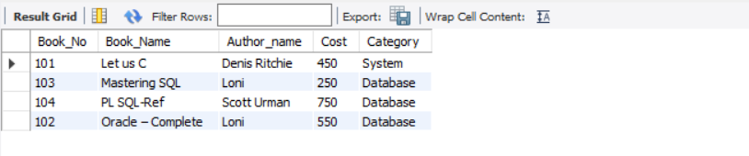

1. select * from book where cost between 500 and 700;

1. select * from book where book_name like 'O%';

1. select * from book where cost < (select avg(cost) from book);

1. create table new_book like book;
2. create table new_kitab as (select * from book);



1. select max(cost) from book as Costliest_Book;

1. select min(cost) from book as Cheapest_book;

1. select author_name from book group by Author_name having count(*) > 1;

1. update book SET cost = cost + 150 where book_name = 'let us c';



1. select book_name, cost from book where category = 'Database' OR category ='System';

1. select book_name from book where category = 'Database';

1. select * from book where cost<500;

